**Will there be some discussion of the non-coding exam questions?**

[Wuddel](https://www.edx.org/courses/MITx/6.00x/2012_Fall/discussion/forum/users/389476) a day ago

I did ok in in the exam, but completely failed in the graph section and had a bit of trouble to determine the runtime in the Borf-problem. Will there be some answers?

1. [2](javascript:void(0)) [xor](https://www.edx.org/courses/MITx/6.00x/2012_Fall/discussion/forum/users/470712)

a day ago

Ask and you shall be answered.

Top of Form



Bottom of Form

1. [1](javascript:void(0)) [zinc](https://www.edx.org/courses/MITx/6.00x/2012_Fall/discussion/forum/users/69335)

about 24 hours ago

Here is a slightly simplified version problem 6 which uses a dictionary instead of a graph class.

I hope this helps.

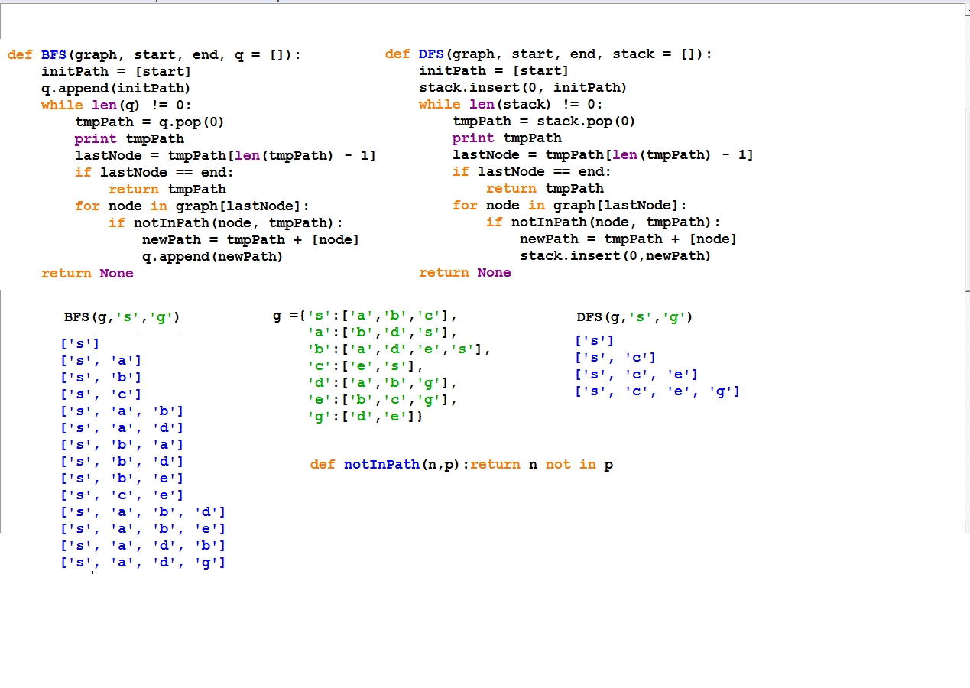

Top of Form



Bottom of Form

1. [1](javascript:void(0)) [jmart79](https://www.edx.org/courses/MITx/6.00x/2012_Fall/discussion/forum/users/523696)

about 19 hours ago

Honestly I could use some guidance on problem 7 (the polyfit example). I was able to come up with an answer...but I don't think it was the most efficient way of doing it.

Was able to come up with c easily by setting x to 0 and the cubic term did not exist.

For the a and b terms though...i solved for a and just iterated through integers and happened to get a perfect fit at x = 2. By luck I was able to get a 0 error when I used b = 1 which also gave me 3/4 for a. Was there a more efficient way to do this?

* + That is coding question, and dealt in other thread. But here is most optimized solution for me (not the clumsier one I passed with in test)

–posted about 19 hours ago by [pyTony](https://www.edx.org/courses/MITx/6.00x/2012_Fall/discussion/forum/users/311172)

* + Picture did not succeed, second try: 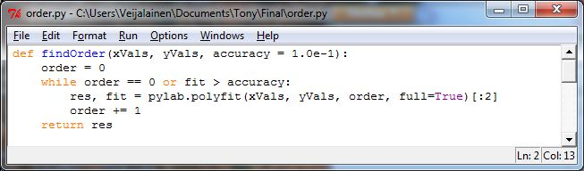

–posted about 19 hours ago by [pyTony](https://www.edx.org/courses/MITx/6.00x/2012_Fall/discussion/forum/users/311172)

* + Maybe I got my question numbers messed up, but I thought the first polyline question did not involve coding? It was simply a what does this program print question?

–posted about 19 hours ago by [jmart79](https://www.edx.org/courses/MITx/6.00x/2012_Fall/discussion/forum/users/523696)

* + My bad, it was the one before, the

0.0 0.75 1.0 1.0

one.

–posted about 18 hours ago by [pyTony](https://www.edx.org/courses/MITx/6.00x/2012_Fall/discussion/forum/users/311172)

* + That's the one!

–posted about 18 hours ago by [jmart79](https://www.edx.org/courses/MITx/6.00x/2012_Fall/discussion/forum/users/523696)